MARCONI INTEL XEON PHI - CINECA CLUSTER, LENOVO SD530/S720AP, INTEL XEON PHI 7250 68C 1.4GHZ/PLATINUM 8160, INTEL OMNI-PATH

|  |  |
| --- | --- |
| **Site:** | [CINECA](https://www.top500.org/site/47495/) |
| **Manufacturer:** | Lenovo |
| **Cores:** | 348,000 |
| **Memory:** | 455,168 GB |
| **Processor:** | Intel Xeon Phi 7250 68C 1.4GHz |
| **Interconnect:** | Intel Omni-Path |
| **Performance** | |
| **Linpack Performance (Rmax)** | 10,384.9 TFlop/s |
| **Theoretical Peak (Rpeak)** | 18,816 TFlop/s |
| **Nmax** | 7,447,776 |
| **HPCG [TFlop/s]** | 68.624 |
| **Power Consumption** | |
| **Power:** |  |
| **Software** | |
| **Operating System:** | Linux |

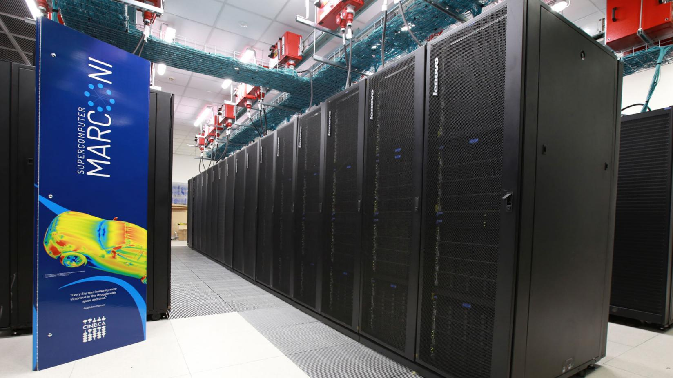

Cineca’s Marconi supercomputer built by Lenovo* utilizes Intel® Xeon® Scalable processors and Intel® Xeon Phi™ processors and Intel® Omni-Path Architecture (Intel® OPA) fabric.

The designers of Marconi built on Cineca’s early experiences with Intel® Xeon® processors and Intel TrueScale network adapters (the pre-cursor to Intel® OPA). For their next-generation supercomputer, they chose Intel® Xeon® processors, Intel® Xeon Phi™ processors, Intel® Xeon® Scalable processors, and the Intel® OPA fabric to interconnect a very large system that could deliver the performance researchers demand to enable new insights through numerical simulation and computational science. The system was built and deployed by Lenovo using their NeXtScale* platform.

Beginning in 2015, the first set of 720 nodes was deployed (Marconi-A1) with 25,920 cores using Intel® Xeon® processor E5-2696 v4. In 2016, Lenovo deployed the largest partition (Marconi-A2) of 244,880 cores across 3,600 nodes of Intel® Xeon Phi™ processor 7250 with 68 cores per node. In 2017, another 110,592 cores were added in 2,304 nodes (Marconi-A3). This gave Cineca a large number of cores across Intel’s multi-core and many integrated core (MIC) architectures. Marconi has consistently placed within the top 20 fastest supercomputers in the world since November of 20162.

**Result**Cineca is a partner of the MaX CoE—Materials Science at the Exascale—European Center of Excellence for HPC applications. It was initially included in 2016 when Marconi was first deployed. It was awarded another three years of inclusion in 2018. Marconi continues to be a critical part of research and design across Europe.

Fifty percent of Marconi’s workloads come from projects across Europe, representing over 100 million Euros in funding. The balance of Marconi is dedicated to researchers within the country. One of the main sciences is materials research, involving compute-intensive electronic structure workloads. Supporting such depth and breadth of computational sciences requires Cineca to be integral in optimizing popular open source codes, such as Quantum Espresso*. Carlo Cavazzoni of Cineca, has contributed to the Quantum Espresso* (QE) project for 20 years, and is integral to optimizing multiple workloads, including QE, on Intel® Xeon Phi™ processor. He has also supported work on proprietary plasma physics codes. Those optimizations have enabled significant speedups on projects running on Marconi’s Intel® Xeon® Scalable processor and Intel® Xeon Phi™  
processor nodes.

Andrea Ferretti is a researcher in the field of condensed matter and solid state physics at Italy’s National Research Council (CNR). Using Marconi, his computational work in ab initio simulations for electronic structure and excitations has been crucial in work that has revealed new electroluminescence properties for graphene nanoribbons (GNR) and abilities to control the coupling of spin interfaces with high thermal stability.

**Solution Summary**Cineca is Italy’s premier center for supercomputing and a key center for computational support for projects across Europe. Marconi is Cineca’s latest HPC resource built on Intel® Xeon® Scalable processors, Intel® Xeon Phi™ processors, and Intel® Xeon® processor E5 v4 family with Intel® OPA as the interconnecting fabric. The system was built by Lenovo and deployed in three phases from 2016 through 2018. Marconi has consistently placed in the top 20 supercomputers on the Top500 list.

**Solution Ingredients**

* Lenovo NeXtScale* platform
* Intel® Xeon® processor E5-2697 v4, Intel® Xeon Phi™ processor 7250, Intel® Xeon® Platinum 8160 processor: total of 6,624 nodes with 381,392 cores
* Intel® OPA edge switches, director switches, and host interfaces